<https://docs.google.com/document/d/1kKeUzUuWFm01WdR86oZv5IO0qIXPMrEdY3pAZ83TAfg/edit?usp=sharing>

PART A:

1. The turn ratio=3:1

2.

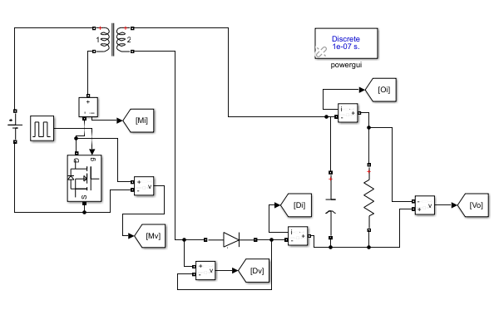

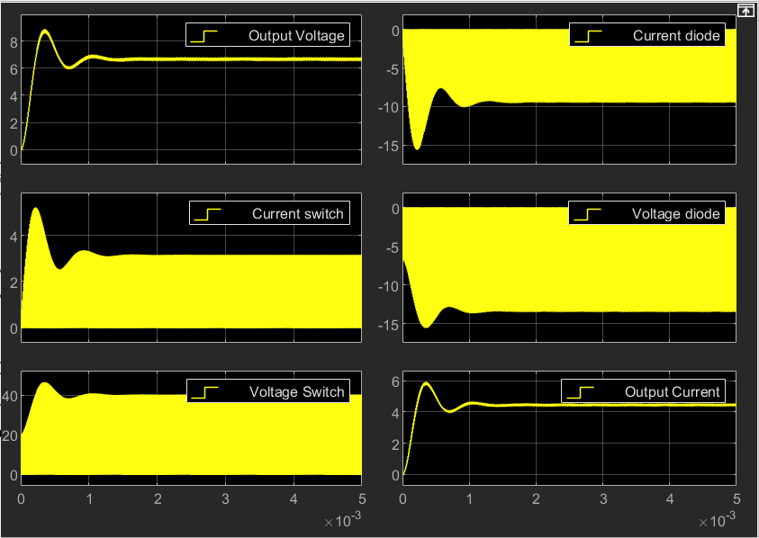

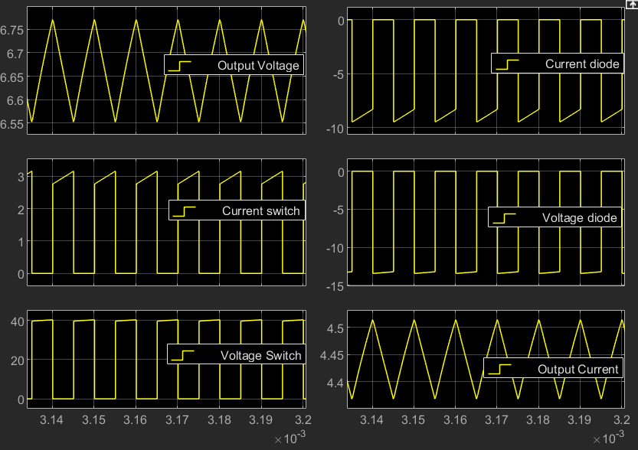

Irms = 3.961 A diode current

Irms = 1.096 A switch current

Vrms = 7.396 V diode voltage

Vrms = 25.82 V switch voltage

Vrms = 4.44 V output voltage

3. The input voltage is varied from 15 V to 20 V (in steps of 1 V) with a fixed load resistance of 15 Ω, and a fixed duty ratio of 45%.

4. Vin = 18 V, and duty ratio of 45 %.

PART B:

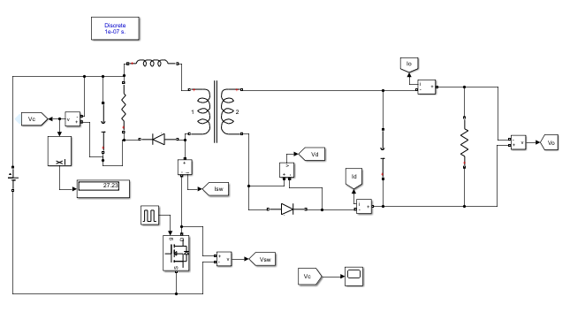

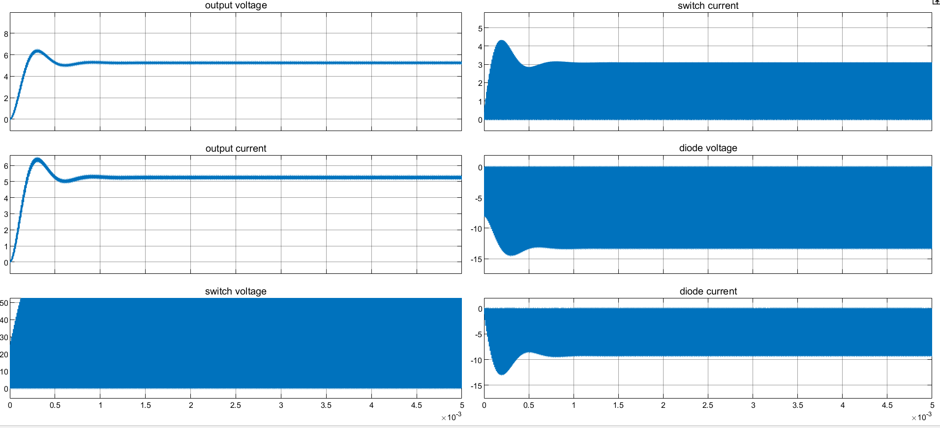

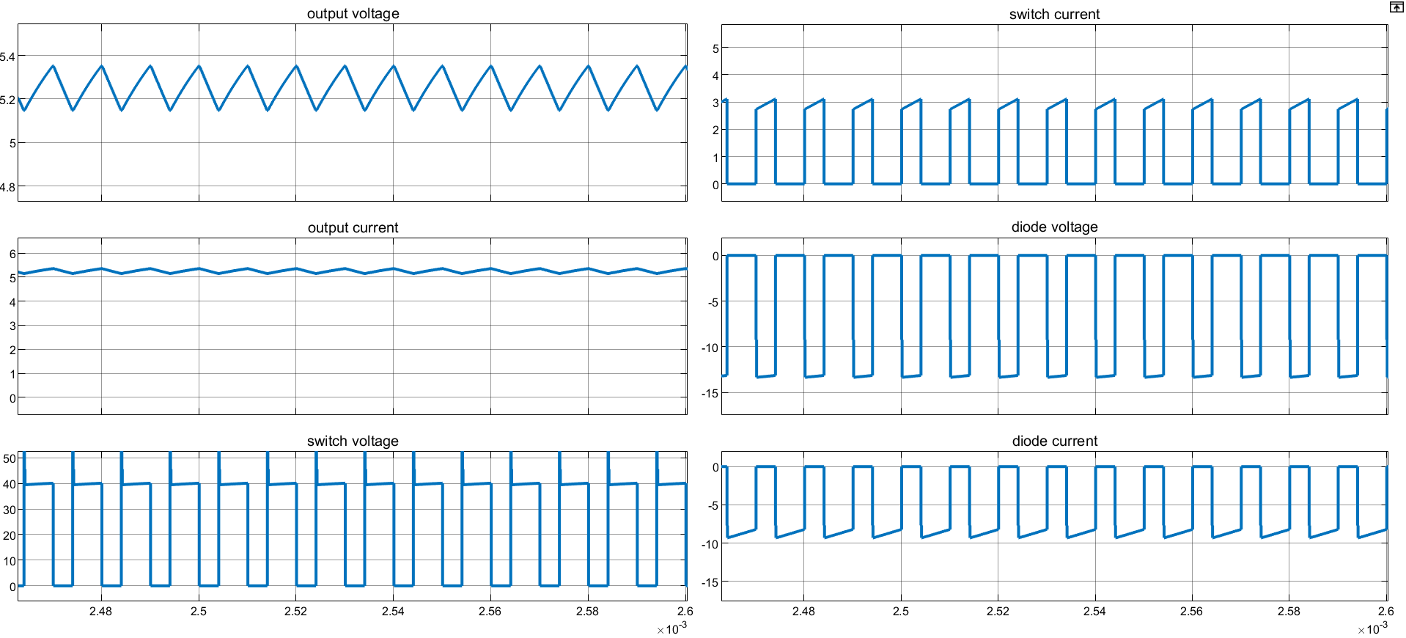

Snubber capacitor voltage 27.36V

Power=27.36^2/5000 = 0.1497